“2021 TransPride Pittsburgh Health and Wellness Conference”

Presented by Central Outreach Wellness Center
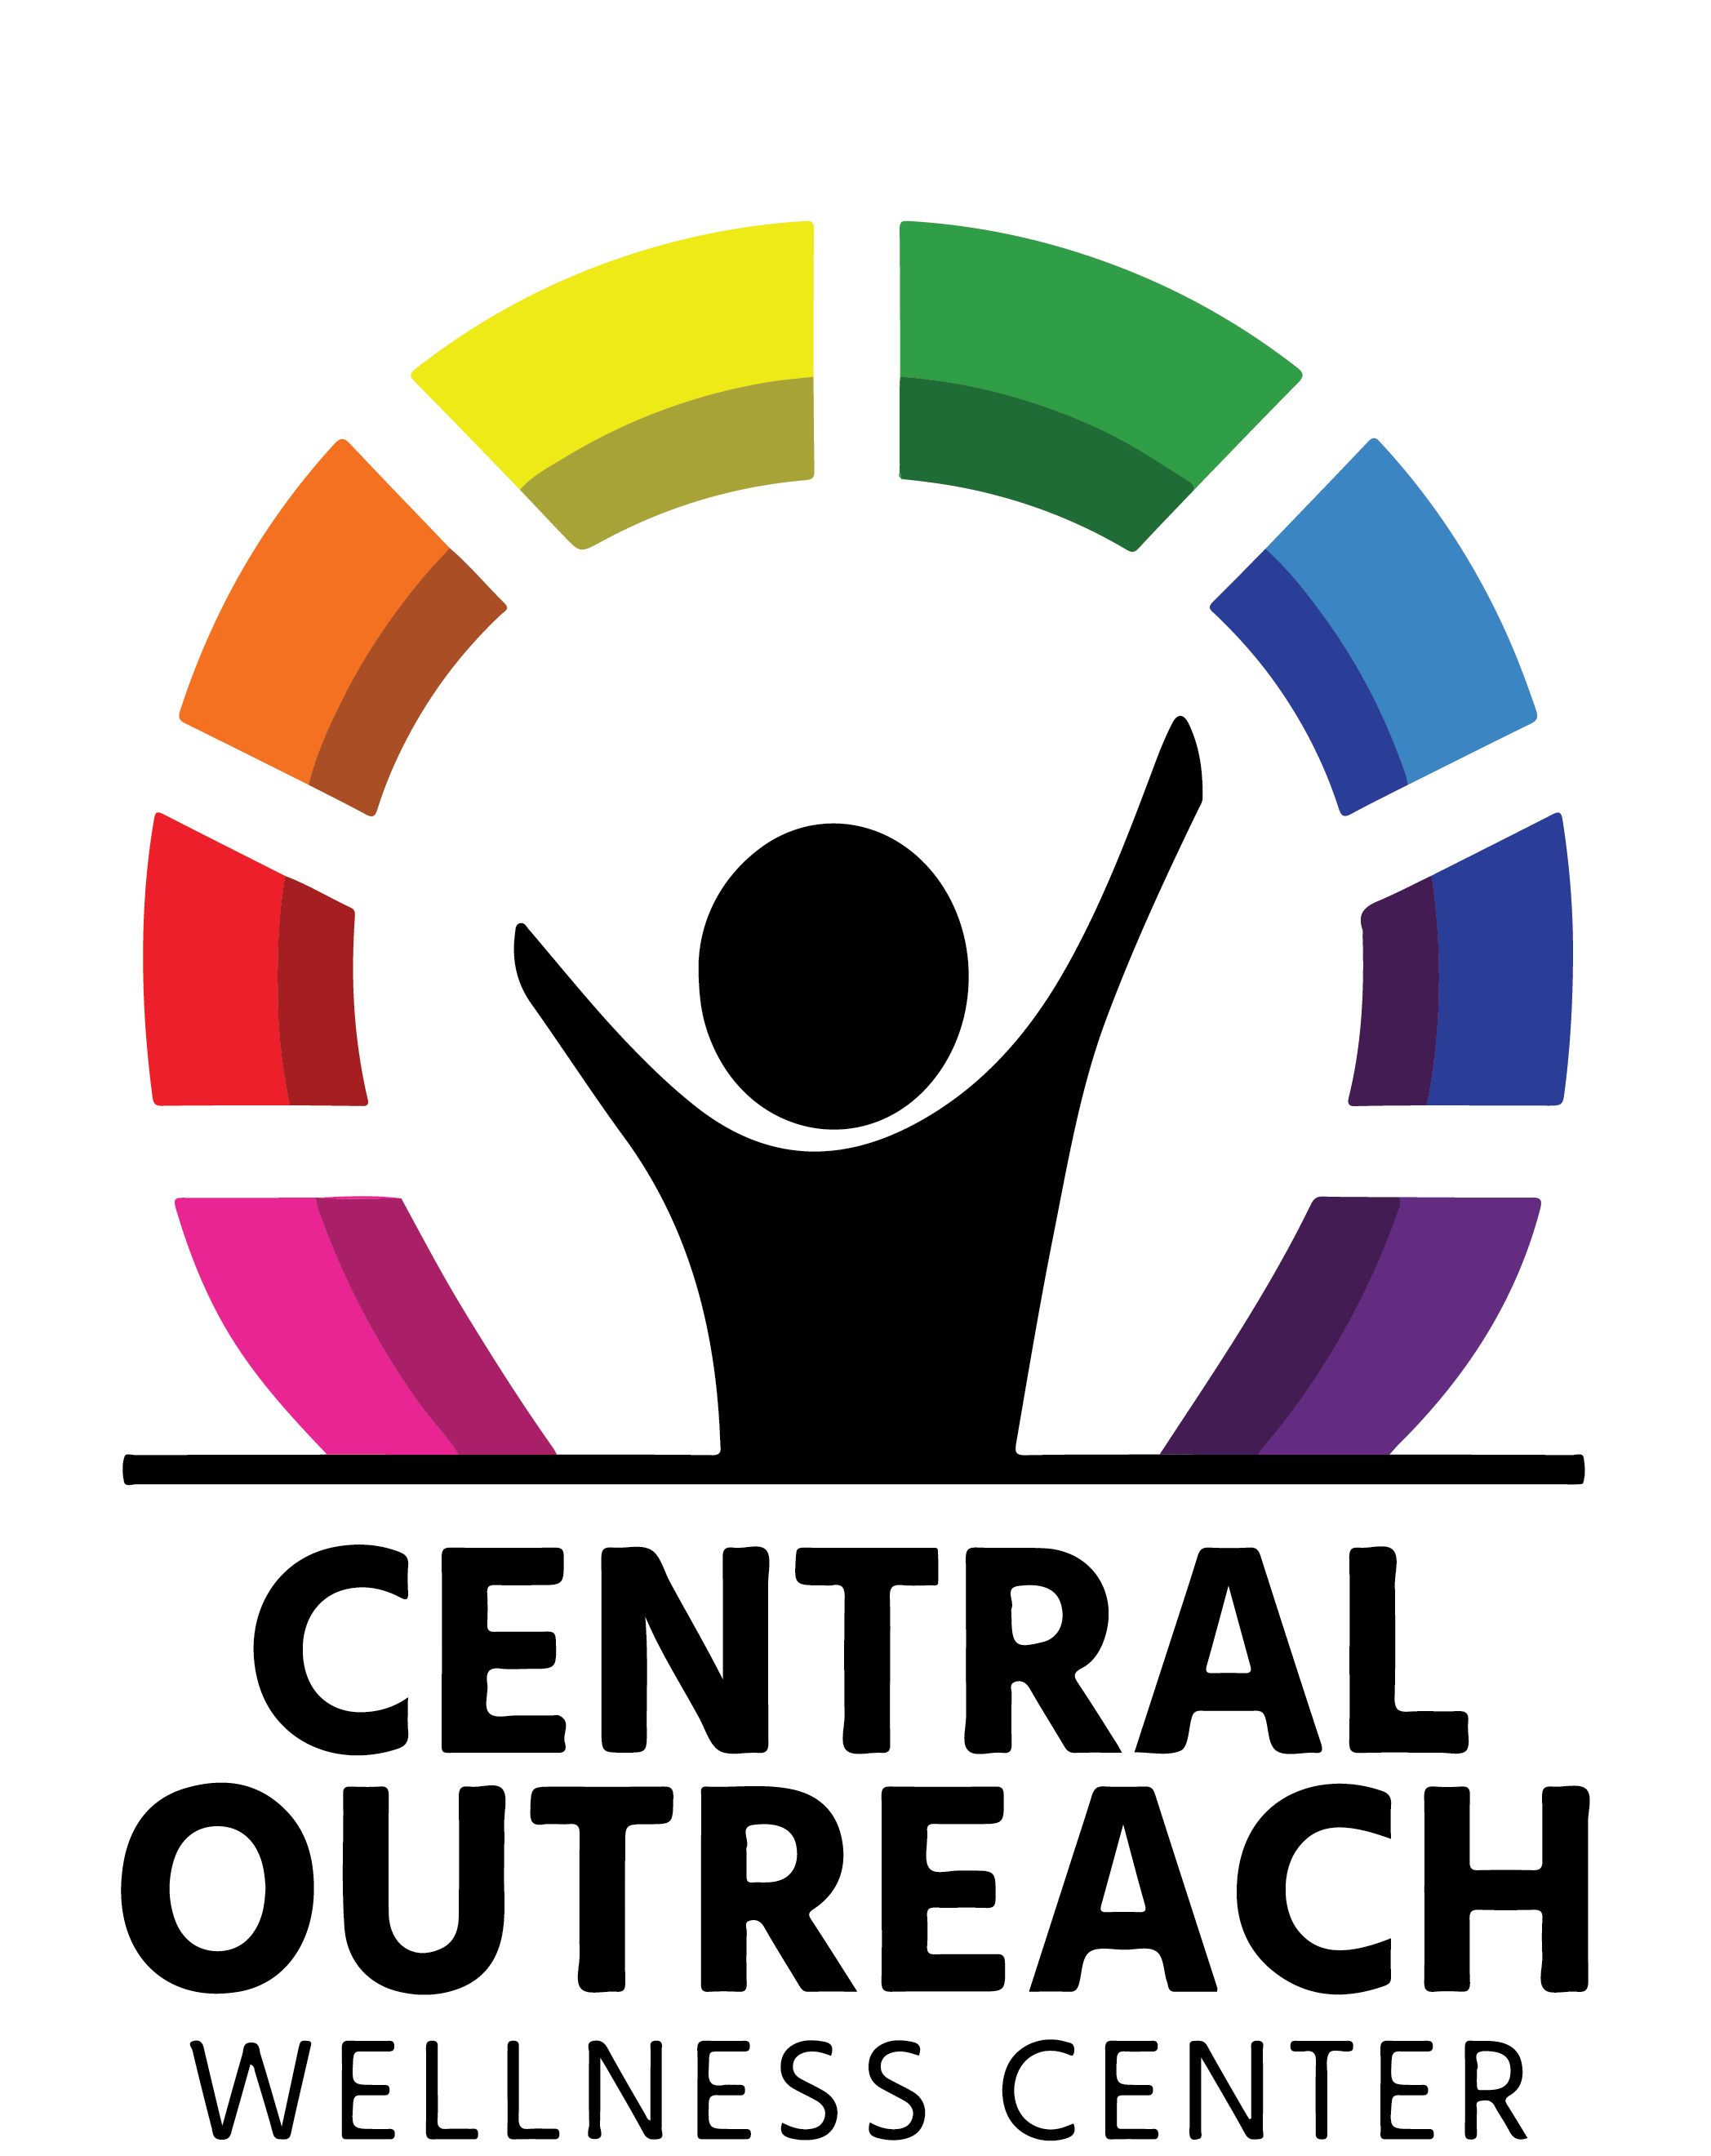

October 14, 15, and 16, 2021

Registration Required - Live Stream Event
Thursday/Friday-ZOOM sign-in at 7:30 AM;
Program: 8:00 AM to 4:45 PM
Saturday - ZOOM sign-in at 8:15 AM;
Program: 8:45 AM to 5:30 PM

Course Directors
J. Coley Alston, MPH, CPH; Morgan Faeder, MD, PhD; Kacie Kidd, MD, MS; Gerald Montano, DO, MS;
Kelly O’Toole, MSW, LCSW; Dana L. Rofey, PhD, FTOS, FAED; Alicyn Simpson, SME; Lyndsey Sickler, BA, SME;
Carol VanZile, LCSW

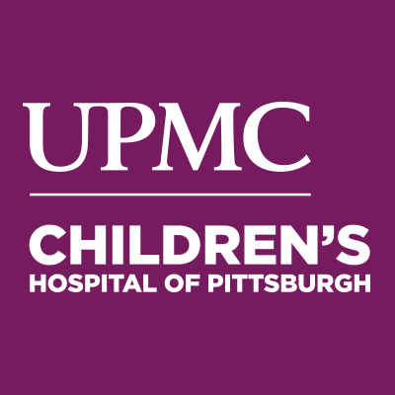
UPMC Center for Continuing Education in the Health Sciences
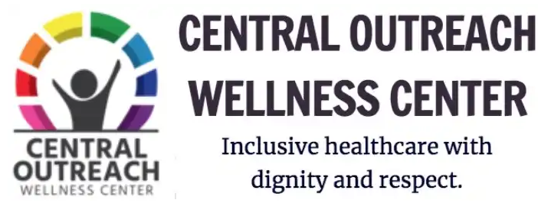

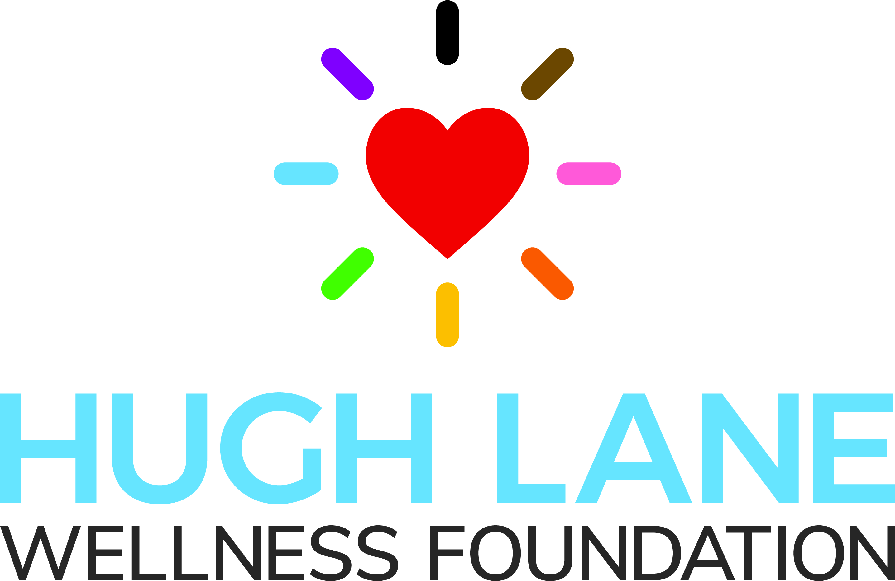
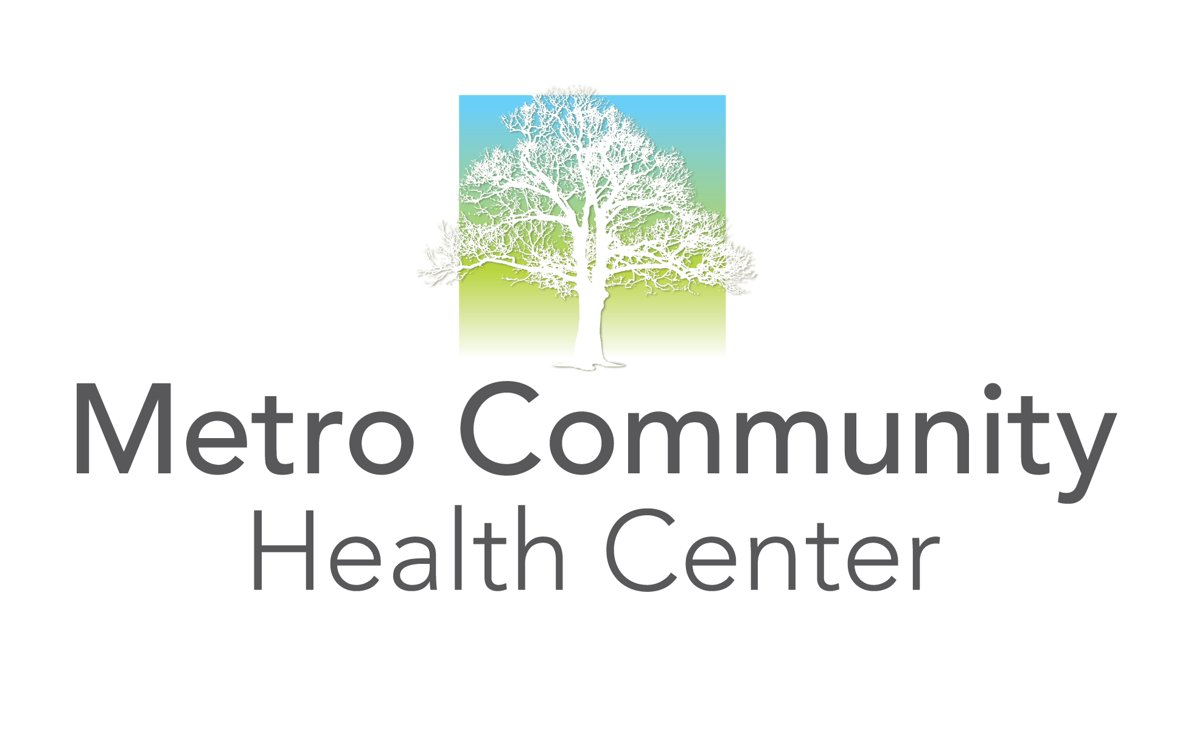
Recovery and Wellness: The Journey Starts Here
A Joint Effort Sponsored by Community Care
Behavioral Health Organization
and UPMC Western Psychiatric Hospital

Introduction

LGBTQIA2S+ people come from all walks of life, all races and ethnicities, all ages, all socio-economic statuses, all parts of the United States and from all over the world. A recent study tells us that gender non-conforming people make up almost 10% of the population, which is significantly more than prior, lower, estimates that were likely due to rampant underreporting. Of this vast transgender and gender diverse demographic, Black, Indigenous, and other People of Color continue to experience tremendous discrimination and inequality in healthcare.

The 2021 TransPride Pittsburgh Health and Wellness Conference perseveres during a time when transgender and gender diverse individuals, particularly young people, are the targets of a coordinated legislative campaign that seeks to revoke their rights to participate in sports as their affirmed gender while also criminalizing and denying critical access to gender-affirming care. This conference rallies against these issues by centering the lives and lived experiences of the transgender and gender non-conforming community. We are striving to bring together not only community members but their families, allies, and healthcare professionals in a space of mutual learning through shared perspectives and experience.

Building off of last year, this year's theme "Rising to the Challenge'', holds the dual meaning of challenging our professional allies to rise to the task of meeting the community where it is while also raising the voices of the gender diverse community alongside or above their own. We have actively recruited speakers who are community members themselves, and we have strongly encouraged all other professional speakers to invite community voices or co-presenters to the table. We truly believe that the best new ideas are forged when communities and institutions are able to come together. We are also firm in our belief that the needs of LGBTQIA2S+ people should always be considered in public health efforts to improve overall health and eliminate health disparities.

Our vision is that all humans can exist in a diverse spectrum of biological characteristics, sexual orientations, gender identities, and other intersectional traits: that anti-racism is the foundation that gender and sexual equality must be built upon. We encourage you, as professionals, to consider the ways in which you can treat transgender, non-binary, other gender diverse, and intersex patients with as much dignity, respect, and clinical competency as cisgender patients.

Through education, dialog, and narrative humility we acknowledge “that our patients' stories are not objects that we can comprehend or master, but rather, dynamic entities that we can approach and engage with, while simultaneously remaining open to their ambiguity and contradiction and engaging in constant self-evaluation and self-critique.” (DasGupta 2008) Comprehensive, institutional, gender diversity and cultural competency is essential to our goal of treating clients and patients exactly as they wish and deserve to be treated.

Our speakers this year will discuss various healthcare needs, transition and de-transition, affirming voice and communication, research, advocacy, legal issues, gender diversity, best practices, and cultural competencies when working with transgender, non-binary, and other gender diverse or intersex persons, and/or their caregivers.

Educational Objectives
At the completion of this program, participants should be able to:
- Describe skill and increased cultural competency for providing mental, medical and other supportive health services to transgender, non-binary, other gender diverse, and intersex individuals.
- Explain the value of lived experience and discuss the societal challenges facing transgender, other gender diverse, and intersex individuals and how best to advocate for improve access to and quality of care.
- Describe the scientific peer-reviewed evidence that supports age-appropriate gender affirming care in contrast to the misinformation and ignorance being used to discredit and discriminate against community members and their care providers.
- Recognize that intersectionality and diversity are the foundations of what it means to be human and that racial, ethnic, gender, and sexual equity must be inclusive and respectful of transgender, non-binary and intersex status and identity.

Who Should Attend
Mental and medical healthcare providers and staff, social workers, community and other service providers, members of the transgender, non-binary, other gender diverse, and intersex communities, youth, families, caregivers, and allies.

Acknowledgements
Thank you to the entire planning committee for the countless hours they committed throughout the year and for their work in developing this conference for all to learn and grow as providers of care for transgender, non-binary, other gender diverse, and intersex individuals: TransPride Pittsburgh, UPMC Western Psychiatric LGBTQ+ Committee, UPMC Children’s Hospital of Pittsburgh, TransYOUniting, Hugh Lane Foundation, and Persad Center.

Course Directors and Committee Members

J. Coley Alston, MPH, CPH (Course Director)
(They/Them/Theirs)
Program Director
Hugh Lane Foundation
Co-Chair, TransPride PGH
Pittsburgh, PA

Charlie Borowicz, MSW, MPH (They/Them/Theirs)
Transgender Health Project Manager
Center for Inclusion Health
Allegheny Health Network
Co-Leader Trans Buddy PGH
Pittsburgh, PA

Morgan Faeder, MD, PhD (Course Director) (He/Him/His)
Director, UPMC Consult Liasison Psychiatry Fellowship
Medical Director, Neuropsychiatry
Assistant Professor of Psychiatry and Neurology
UPMC Western Psychiatric Hospital
University of Pittsburgh School of Medicine
Pittsburgh, PA

Kacie Kidd, MD (Course Director) (She/Her/Hers)
Assistant Professor of Pediatrics
Division of Adolescent Medicine, Department of Pediatrics
Medical Director, Gender & Sexual Development Clinic
WVU Medicine Children's
West Virginia University School of Medicine
Morgantown, WV

Gerald Montano, DO, MS (Course Director) (He/Him/His)
Assistant Professor of Pediatrics
University of Pittsburgh School of Medicine
Medical Director, Gender and Sexual Development Program
UPMC Children’s Hospital of Pittsburgh
Pittsburgh, PA

Kelly O’Toole, MSW, LCSW (Course Director) (She/Her/Hers)
Director of Clinical Care Services, Adult Services
UPMC Western Psychiatric Hospital
Pittsburgh, PA

Dana L. Rofey, PhD, FTOS, FAED (Course Director)
(She/Her/Hers)
Director of the Pittsburgh Obesity, Weight,
and Emotion Research for Gender Diverse Youth (POWER-G) Lab
Associate Professor, Department of Psychiatry, Pediatrics, Psychology, CTSI
University of Pittsburgh Medical School
Pittsburgh, PA

Lyndsey Sickler, BA, SME (Course Director) (They/Them/Theirs)
Youth Program Manager
Pittsburgh Youth Haven
Co-Chair, TransPride Pittsburgh
Pittsburgh, PA

Alicyn Simpson, SME (Course Director) (She/Her/Hers)
Community Navigator
Gender and Sexual Development Program
Center for Adolescent and Young Adult Health
UPMC Children’s Hospital of Pittsburgh
Co-Founder/Co-Leader Trans Buddy PGH
Pittsburgh, PA

Carol VanZile, LCSW (Course Director) (She/Her/Hers)
Director BH Regulatory, Compliance
and Accreditation/Compliance Officer
UPMC Western Psychiatric Hospital
Pittsburgh, PA

Keynote Speakers and Faculty

Noah Adams, MSW (He/Him/His)
PhD Student
Center for Applied Transgender Studies, Junior Fellow
University of Toronto
Toronto, Ontario
Canada

Leo Bake (They/Them, Xe/Xem)
Education Facilitator
Women’s Center & Shelter of Greater Pittsburgh
Pittsburgh, PA

Adrian J. Ballard, MSW, LCSW (He/Him/His)
Doctoral Student, School of Social Work
University of Pittsburgh
Pittsburgh, PA

Arlene Baratz, MD (She/Her/Hers)
Medical and Research Policy for Intersex/
Differences of Sex Development
University of Pittsburgh School of Medicine
Pittsburgh, PA

Braeden Bash, PA (They/Them/Theirs)
Physician Assistant
Allies for Health and Wellbeing
Pittsburgh, PA

Demond E. Bledsoe, PhD, LPC (He/Him/His)
Sr. Program Director
UPMC Western Psychiatric Hospital
Pittsburgh, PA

Leyna Bonanno, MS (She/Her/Hers)
Behavioral Health Therapist
UPMC Western Psychiatric Hospital
Pittsburgh, PA

Justice Renée Bovee (She/Her/Hers)
Former Young Earth Christian Fundamentalist Minister, Trans-Female, Founder of Secular North
Minneapolis, MN

Rashod Xavier Brown, BS (He/Him/His)
Community Health Specialist
Project Silk
Pittsburgh, PA

Bria Brown-King, SME (She/Her/Hers, They/Them/Theirs)
Director of Engagement

interACT: advocates for intersex youth

Northampton, MA

Ashley T. Brundage (Keynote Speaker) (She/Her/Hers)
Founder & President
Empowering Differences
Tampa, FL

Johanna Burnett, PhD (She/Her/Hers)
Founder, Parent2Parent
Adjunct Professor
Duquesne University
Pittsburgh, PA

Charley Burton (He/Him/His)
Recovery Advocate for Transmen
Facilitator Big Book Studies and Step Meetings
Charlottesville, VA

Tamar C. Carmel, MD (He/Him/His)
Medical Director of Mental Health Services
Central Outreach Wellness Center
Clinical Assistant Professor
University of Pittsburgh School of Medicine,
Department of Psychiatry
Pittsburgh, PA

Angela Carter, ND (They/Them/Theirs)
Program and Implementation Manager for Measure 110
Oregon Health Authority
Co-Chair; OHSU Transgender Health Community Advisory Board
Portland, OR

Carla Chugani, PhD, LPC (She/Her/Hers)
Assistant Professor of Pediatrics and Psychiatry
DBT-Linehan Board of Certification, Certified DBT Clinician™
University of Pittsburgh School of Medicine
Division of Adolescent and Young Adult Medicine
Pittsburgh, PA

Jennifer Cleary (Ze/Hir, She/Her)
Speech-Language Pathologist
Trans Voice Initiative founding member
San Francisco, CA

Katharine B. Dalke, MD, MBE (She/Her/Hers)
Director, Office for Culturally Responsive Health Care Education
Assistant Professor of Psychiatry and Behavioral Health
Co-Chair, LGBTQ and Allies Affinity Network
Resource Group
Penn State College of Medicine
State College, PA

Venus De Mars (She/Her/Hers)
Musician/Performer/Singer songwriter/Rock Band Leader
Minneapolis, MN

Erica Dommasch, MD, MPH (She/Her/Hers)​
Assistant Professor, Harvard Medical Center
Beth Israel Deaconess Medical Center
Department of Dermatology
Boston, MA

Antonia D’orsay, PhD, MS, MA (She/Her/Hers)
Director of Trans Services
Triumph Borrego Health
Borrego Springs, CA

Jett Downey, BA (She/Her/Hers)
Creative Musician
Thomas J Watson Fellow
Producer Jett Downey Music
Pittsburgh, PA

Phil Duran, JD (He/Him/His)
Director of Advocacy & Research
RAINBOW HEALTH
2577 Territorial Road
Saint Paul, MN

Kristen Eckstrand, MD, PhD
(She/Her/Hers, They/Them/Theirs)
Fellow
Child and Adolescent Psychiatry
Post-Doctoral Fellow at the University of Pittsburgh
University of Pittsburgh School of Medicine
UPMC Western Psychiatric Hospital
Pittsburgh, PA

Jason D. Flatt, PhD (He/Him/His)
Assistant Professor, Social and Behavioral Health Program
UNLV School of Public Health, Las Vegas, NV
Instructor, Center for Social and Urban Research
University of Pittsburgh
Pittsburgh, PA

Cori Fraser, MSW, LSW (They/Them)
Executive Director
Pittsburgh Center for Autistic Advocacy
Pittsburgh, PA

José Garth (He/Him/His)
Community Education Coordinator
Gwen’s Girls
Pittsburgh, PA

Rachel E. Gartner, PhD (She/Her/Hers)
Assistant Professor
School of Social Work
University of Pittsburgh
Pittsburgh, PA

J. Joy Gero, PsyD, LPC (She/Her/Hers)
Director, Population Health & Improvement
Program Manager of LGBTQ Health Initiatives
Health Services Division
University of Pittsburgh Medical Center
Pittsburgh, PA

Ahmed Ghuman, PsyD, MBA, LPC (He/Him/His)
Associate Director of Strategic Programs & Services
University of Pittsburgh
University Counseling Center
Pittsburgh, PA

AC Goldberg, CCC-SLP (He/Him/His
Speech-Language Pathologist
Trans Voice Initiative founding member
Boston, MA
Joanne Goodall, CRNP (She/Her/Hers)
Center for Adolescent and Young Adult Health
UPMC Children’s Hospital of Pittsburgh
Pittsburgh, PA

Victoria L. B. Grieve, PharmD (She/Her/Hers)
Department of Pharmacy and Therapeutics
Assistant Professor: Pharmacy and Therapeutics
Adjunct Professor: Information Sciences
Affiliated Faculty: Gender and Women's Studies
University of Pittsburgh
Pittsburgh, PA

Lorelei J. Grunwaldt, MD, FACS, FAAP (She/Her/Hers)
Associate Professor of Plastic Surgery
Children's Hospital of Pittsburgh of UPMC
Director, Vascular Anomalies Center
Director, Brachial Plexus Clinic
Pittsburgh, PA

Shireen Haq, MPH (She/Her/Hers)
Program Director
National Network Development & Strategic Expansion
UPMC Health Plan
Pittsburgh, PA

Preston Heldibridle (He/Him/His)
Executive Director
Pennsylvania Youth Congress
Harrisburg, PA

Ken Ho, MD, MPH (He/His)
Assistant Professor
Department of Medicine, Division of Infectious Diseases
University of Pittsburgh School of Medicine
Pittsburgh, PA

Ruchi Kapila (She/They)
Speech-Language Pathologist
Trans Voice Initiative Founding Member
Hayward, CA
John Ingle, MD (He/Him/His)
Laryngologist
Founder, University of Rochester Medical Center
Voice Center
Rochester, NY

RaNaja Kennedy, B.S. (She/Her/Hers)
Community Engagement Facilitator
Clinical and Translational Science Institute
University of Pittsburgh
Pittsburgh, PA

Ralph Jonathan Klotzbaugh, FNP-BC, PhD (He/Him, They/Them)
Assistant Professor
Duquesne University
Pittsburgh, PA

Janice Kochik, CRNP (She/Her/Hers)
Street Medicine, Nurse Practitioner
Central Outreach Wellness Center
Pittsburgh, PA

Michael R. Komo, JD (He/Him/His)
Attorney, Chair of the LGBT ERG,
Professional Development Manager - K&L Gates LLP
Chair of the ACBALGBT LGBT Rights Committee
Pittsburgh, PA

Janet Leung, MD (She/Her/Hers)
Clinical Assistant Professor
Associate Program Director in Quality
Quality and Transgender Lead
University of Pittsburgh Medical Center
Pittsburgh, PA

Ellie Zara Ley, MD (She/Her/Hers)
Plastic and Reconstructive Surgeon
The Meltzer Clinic
Scottsdale, AZ

Elizabeth Lilly, MBA (She/Her/Hers)
IT Service Manager and co-lead of the LGBTQ enterprise resource group
Land O’Lakes, Inc.
Minneapolis, MN

Kathy McQuillan, MA (She/Her/Hers)
Clinical Therapist
Persad Center
Pittsburgh, PA

Sarah L Miller, CRNP (She/Her/Hers)
Nurse Practitioner
Central Outreach Wellness Center
Pittsburgh, PA

Sean Moundas, PsyD (They/Them/Theirs)
Assistant Director-Doctoral Psychology Training
University Counseling Center
University of Pittsburgh
Pittsburgh, PA

Kyle Orwig, PhD (He/Him/His)
Professor of Obstetrics, Gynecology and Reproductive Sciences
Director, UPMC Magee Center for Reproduction and Transplantation
Director, UPMC Fertility Preservation Program
Magee-Womens Research Institute
University of Pittsburgh School of Medicine
Pittsburgh, PA

John Henry Y. Pang, MD (He/Him/His)
Assistant Professor of Surgery
Dept of Surgery/Division of Plastic Surgery
Icahn School of Medicine, Mt Sinai Health System
Brooklyn, NY

Joseph Pariser, MD (He/Him/His)
Assistant Professor of Urology
Associate Fellowship Director
Genitourinary Reconstruction/Gender Affirmation Surgery
University of Minnesota
Minneapolis, MN

Raquelle Paulsen (She/Her/Hers)
Medical Caseworker
University of Minnesota Youth and AIDS Project
Minneapolis, MN

J. Klint Peebles, MD FAAD
Department of Dermatology
Kaiser Permanente, Mid-Atlantic Permanente Medical Group
Co-Chair, American Academy of Dermatology Expert Resource Group on LGBTQ/SGM Health
Washington, DC

Ry Pilchman (They/Them/Theirs)
Speech-Language Pathologist
Trans Voice Initiative Founding Member

New York, NY
Maya Ragavan, MD, MPH, MS (She/Her/Hers)
Assistant Professor of Pediatrics in the Division of General Academic Pediatrics
School of Medicine’s Department of Pediatrics
University of Pittsburgh
Pittsburgh, PA

Nick Ripley, JD (They/Them/Theirs)
Juris Doctor
American University Washington College of Law
Washington, DC

Lauren R. Risser, MPH, CHES (She/Her/Hers)
Senior Research Coordinator, Division of Adolescent and Young Adult Medicine
University of Pittsburgh
Pittsburgh, PA

Mary-Wren Ritchie (She/Her/Hers)
Sex Educator
Pittsburgh, PA

Sarah Rosso, MA (She/Her/Hers, They/Them/Theirs)
Executive Director
Hugh Lane Wellness Foundation
Pittsburgh, PA

Jennifer Rozell-Whitaker LPC, ATR-BC (They/Them, She/Her)
Therapist and Group Practice Owner
Artful Therapy
Monroeville and Pittsburgh, PA

Naiymah Sanchez (keynote speaker) (She/Her/Hers)
Trans Justice Coordinator
American Civil Liberties Union (ACLU)
Philadelphia, PA

Bee Schindler, LMSW, EdD (candidate) (They/Them/Theirs)
Diversity and Inclusion Training Manager
Health Science Diversity, Equity and Inclusion unit
University of Pittsburgh
Pittsburgh, PA

Alexander Smithson (keynote speaker) (He/Him/His)
Proud Haven Board Member
Trans YOUniting Board Member
Pittsburgh, PA

Julie M. Sroga-Rios, MD (She/Her/Hers)
Assistant Professor
University of Pittsburgh Physicians
Department of Obstetrics, Gynecology, and Reproductive Science
Director, Center for Fertility & Reproductive Endocrinology
The University of Pittsburgh School of Medicine
Pittsburgh, PA

Sarah A. Tilstra, MD, MS, FACP (She/Her/Hers)
Director, Women's Health Track, UPMC Internal Medicine Residency Program
Associate Professor of Medicine
Division of General Internal Medicine, University of Pittsburgh Medical Center
Pittsburgh, PA

Wendy Vastine, CCC-SLP (They/Them/Theirs)
Speech-Language Pathologist
Trans Voice Initiative Founding Member
San Pablo, CA

Dave West, MA (He/Him/His)
President, PFLAG PGH
Advocacy, Education, Support
English Teacher, North Allegheny Senior High School
Pittsburgh, PA

Shanon Williams-Hughes, BASW (She/Her/They)
Chief Executor
Self-Care Housekeeping
Pittsburgh, PA

Ann Williamson PT, DPT (She/Her/Hers)
Associate Professor, Director of Clinical Education
Doctor of Physical Therapy Program
Chatham University
Pittsburgh, PA

Selma Feldman Witchel, MD (She/Her/Hers)
Professor of Pediatrics
UPMC Children’s Hospital of Pittsburgh
University of Pittsburgh School of Medicine
Pittsburgh, PA

Steven R. Wolfe, DO, MPH, FAAFP, AAHIVS (He/Him/His)
Dean of Medical Students
Allegheny Health Network
GBTQIA and HIV Primary Care Physician
Clinic Professor of Family Medicine, LECOM
Associate Clinical Professor
Drexel’s Department of Family and Community Medicine
Pittsburgh, PA

For additional information regarding presenters or presentations, please contact Doreen Barkowitz at barkowitzdh@upmc.edu.

Agenda – October 14, 2021

7:45 to 8:00 AM ZOOM Sign-In

8:00 to 9:30 AM Daily Opening Keynote
The Lived Experience of an Afro-Latina Transwoman
Naiymah Sanchez

9:30 to 9:45 AM Break

9:45 to 10:45 AM Breakout Sessions I

- Sexual Orientation and Gender Identity (SOGI) Data Collections: Promoting Best Practices for the Care of LGBTQ+ People
(Medical) Joy Gero, PsyD, LPC
- Building Equity in University-Community Research Relationships
(Advocacy) Bee Schindler, LMSW, EdD candidate; Maya Ragavan, MD, MPH, MS;
RaNaja Kennedy, BS
- The Blueprint: Bigger than the Picture they Framed Us to See
(Community) Coley Alston, MPH, CPH
- Working with High-Risk Populations
(Medical) Joanne Goodall, CRNP; Sarah Miller, CRNP; Janice Kochik, CRNP
- Creating Positive Behavioral Healthcare Experiences in the Black Transgender Community
(Behavioral) Demond Bledsoe, PhD, LPC

10:45 to 11:00 AM Break

11:00 AM to 12:00 PM Breakout Sessions II

- Fertility Preservation for Transgender Individuals
(Medical/Research) Kyle Orwig, PhD
- Working with People Experiencing Higher Risk
(Medical/Behavioral) Joanne Goodall, CRNP; Sarah Miller, CRNP; Janice Kochik, CRNP
- Gender Diversity as a Foundation for Healthcare
(Medical/Behavioral) Alicyn Simpson, SME; Gerald Montano, DO, MS
- Trans Inclusive Workplaces – The Hard Parts
(Behavioral) Liz Lilly, MBA
- Affirming Gender Diverse Youth
(Behavioral) Sarah Rosso, MA

12:00 to 1:00 PM Lunch
Covid-19 Vaccination Info Session – Resources and Support
Lyndsey Sickler, BA, SME

1:00 to 2:00 PM Breakout Sessions III

- Understanding Aging Health Needs for Gender Minority Older Adults
(Medical) Jason Flatt, PhD
- Sexual and Reproductive Healthcare for Gender-Diverse Youth
(Medical) Gerald Montano, DO, MS
- The Intersection of Research and Advocacy in Transgender Health
(Research) Kacie Kidd, MD, MS
- Trans Parent Support Group – Helping Parents and Family Move from Rejection to Acceptance
(Behavioral) Kathleen McQuillan, MA
- Depathologization and Information Consent
(Medical) Antonia D’orsay, PhD, MS, MA

2:00 to 2:15 PM Break

2:15 to 3:15 PM Breakout Sessions IV

- Safer Sex and Sexual Wellness During the Pandemic
(Medical) Ken Ho, MD, MPH
- Panel Presentation: Occupational and Physical Therapy Education, and Clinical Practice for the LGBTQ+ Community: Graduate Student Perspectives
(Medical) Anne Williamson, PT, DPT
- LGBT Legal / Employee Resource Group
(Legal) Michael Komo, JD
- How to Write a Gender Affirming Surgery Letter
(Behavioral) Tamar Carmel, MD
- Grit and Gratitude: The Power of Post-Traumatic Growth
(Behavioral) Sean Moundas, PsyD
- Surgical Options and Consideration for Gender Affirming Genital Surgery
(Medical/Surgical) Joseph Pariser, MD

3:15 to 3:30 PM Break

3:30 to 5:00 PM Daily Closing Keynote
Reflections on the Changes Between the Old and New World of Trans-Experience
Venus De Mar

5:00 to 5:15 PM Sponsor Advertising

5:15 PM Adjournment

Agenda – October 15, 2021

7:45 to 8:00 AM ZOOM Sign-In

8:00 to 9:30 AM Daily Opening Keynote
Empowering Difference
Ashley T. Brundage

9:30 to 9:45 AM Break

9:45 to 10:45 AM Breakout Sessions I

- An Endocrinologist’s Perspectives on Long-Term Effects of Hormonal Treatment and on Alternate Treatment Options
(Medical) Janet Leung, MD
- Transgender Fertility Preservation: Current State, and How We Can Improve
(Medical) Julie Rios, MD
- Neuroqueer: An Art Therapy Approach
(Behavioral) Jennifer Rozell-Whitaker, LPC, ATR-BC
- Letter Writing for Gender Affirming Care
(Behavioral) Kristen Eckstrand, MD, PhD
- Considerations in Gender Diverse Dermatology
(Medical) Erica Dommasch, MD, MPH; Klint Peebles, MD, FAAD
- Gaps and Missed Opportunities While Providing GAC and Medical Care to TGNC Individuals
(Medical) Braeden Bash, PA

10:45 to 11:00 AM Break
11:00 AM to 12:00 PM Breakout Sessions II

- Trans and Non-binary Sexual Health
(Medical) Angela Carter, ND
- Being an Accomplice: Advocating for Trans People in Professional Spaces
(Medical/Advocacy) Morgan Faeder, MD, PhD
- How to Incorporate Gender Affirming Education into Your Everyday Teaching
(Medical) Sarah Tilstra, MD, MS, FACP
- Advocating for an Intersex-Affirming Future
(Medical/Advocacy) Bria Brown-King, SME; Arlene Baratz, MD
- Head | Heart | Home
(Behavioral) Shanon Hughes, BASW
- Reimagining Allyship Through Storytelling
(Behavioral) Sean Moundas, PsyD; Ahmed Ghuman, PsyD, MBA, LPC

12:00 to 1:00 PM Lunch
Covid-19 Vaccination Info Session – Resources and Support
Lyndsey Sickler, BA, SME

1:00 to 2:00 PM Breakout Sessions III
- Use of Hormone Blockers
(Medical) Selma Witchel, MD
- Transmen in Recover
(Behavioral) Charley Burton, SME
- Sex Ed for All
(Community) Mary-Wren Ritchie, SME
- Affirming Care for Patients with Intersex Traits
(Medical) Katie Dalke, MD, MBE
- Centering Trans Students’ Experiences to Transform Campus Sexual Violence Prevention
(Community/Research) Rachel Gartner, PhD; Lauren Risser, MPH, CHES; Adrian J. Ballard, MSW, LCSW
- Research Abstracts and Community Updates
(Research/Community) Kacie Kidd, MD

2:00 to 2:15 PM Break

2:15 to 3:15 PM Breakout Sessions IV
- Advancing TGNC Leadership in the Medical Field: A TGNC-Led Panel Discussion
(Medical) AC Goldberg, CCC-SLP
- Pharmacology of HRT
(Medical) Victoria Grieve, PharmD
- Beyond Common: Medical Cases in Gender Affirmation Care
(Medical) Stephen R. Wolfe, DO, MPH, FAAFP, AAHIVS
- Top Surgery (Content Warning)
(Medical/Surgical) Lorelei Grunwaldt, MD, FACS, FAAP
- Dialectical Behavior Therapy: Overview of the Treatment and Development of an Intensive Outpatient Program for LGBTQIA+ Individuals
(Behavioral) Carla Chugani, PhD, LPC; Dana Rofey, PhD, FTOS, FAED; Leyna Bonanno, MS

3:15 to 3:30 PM Break

3:30 to 5:00 PM Daily Closing Keynote
A Transmasculine Perspective
Alexander Smithson

5:00 to 5:15 PM Sponsor Advertising

5:15 PM Adjournment

Agenda – October 16, 2021

9:30 to 10:00 AM ZOOM Sign-In

10:00 to 11:00 AM Breakout Sessions I
- Comprehensive Surgical Care for the TGNB Patient (Content Warning)
(Medical/Surgical) John Henry Pang, MD
- Dr. Magnus Hirschfeld and A Magic Modern History of Trans Healthcare
(Community/General) Tanith Broom, SME
- Disabled and Trans: Confronting Disparities
(Community) Cori Fraser, MSW, LSW
- A Look Through a Provider Consumer Lens
(Community) Raquelle Paulsen, MS
- Research Considerations When Working with Gender Minority Participants
(Research/General) Ralph Klotzbaugh, FNP-BC, PhD
- Getting to Yes: Fighting Insurance Denials of Gender-Affirming Care – Part 1
(Advocacy/General) Phil Duran, JD

11:00 to 11:15 AM Break
11:15 AM to 12:15 PM Breakout Sessions II
- Gender Affirming Phonosurgery: The Current State of the Field
(Medical/Surgical) John Ingle, MD
- Trans Aspies and Auties Discussion Group
(Community Only) Noah Adams, PhD candidate
- Anime, Cosplay and Fan Art Therapeutic Art Group
(Behavioral/Community) Jennifer Rozell-Whitaker, LPC, ATR-BC
- What A Character: A Musical Exploration of Characters from Transgender Historical Fiction (no CE/CME credits)
(Community) Jett Downey
- Getting to Yes: Fighting Insurance Denials of Gender-Affirming Care – Part 2
(Advocacy/General) Phil Duran, JD
- Considerations in Gender Diverse Dermatology
(Medical) Erica Dommasch, MD, MPH; Klint Peebles, MD, FAAD

11:00 AM to 12:30 PM Morning Keynote
Masculinizing Gender Affirming Surgical Options (Content Warning)
Ellie Zara Ley, MD

12:30 to 1:00 PM Lunch
Covid-19 Vaccination Info Session – Resources and Support
Lyndsey Sickler, BA, SME

1:00 to 2:30 PM Afternoon Keynote
Feminizing Gender Affirming Surgical Options (Content Warning)
Ellie Zara Ley, MD

1:00 to 2:00 PM Breakout Sessions III

- The New Trans Discrimination Playbook
(Legal/Advocacy) Nick Ripley, JD
- Gender and the Bible
(General/Community) Johanna Burnett, PhD
- Top Surgery Show and Tell
(Community Only) Coley Alston, MS, SME
- Defining Intimate Partner and Domestic violence in Queer and Trans Relationships
(Community) Leo Bake, BA
- Social Media Usage Among Transgender People: A Phenomenological Study
(Research/General) Leyna Bonanno, MS

2:30 to 2:45 PM Break

2:45 to 3:45 PM Breakout Sessions IV
- The 4 A's: Behavioral Model for Diversity, Inclusion, and Equity
(General/Community) Antonia D’orsay, PhD, MS, MA
- Beyond Common: Medical Cases in Gender Affirmation Care
(General/Advocacy) Preston Heldibridle, SME
- Lessons Learned, Working with At Risk Transgender and Non-Binary Youth
(Community) Lyndsey Sickler, BA, SME; Coley Alston, MS
- Intersectional Trauma-Informed Gender Affirming Voice
(Community) Trans Voice Initiative; Wendy Vastine, CCC-SLP
- Supporting the Supporters
(Community/Caregivers) Dave West, MA

3:45 to 4:00 PM Break

4:00 to 5:00 PM Breakout Sessions V
AA. Ciscentrism: Critical Trans Theory
(General/Community) Antonia D’orsay, PhD, MS, MA
BB. Black QT Chat (no CE/CME credits available)
(Community Only) Coley Alston, MS, SME
- Trans Art: Community Support and Healing (no CE/CME credits available)
(Community) Lyndsey Sickler, BA, SME; Rashod Brown, SME
DD. Assessing LGBTQ+ Affirming Providers
(Community) Shireen Haq, MPH
- Moving Forward: From Fundamentalist Hate to Embracing Freedom
(General/Community) Justice Renée Bovee, SME

5:00 to 5:30 PM Conference Closing Event – Thank you Planning Committee, Keynotes, Speakers, Sponsors, Attendees

5:30 PM Adjournment

Continuing Education Credits – October 14, 2021 (5.5 CE/CME credits)

In support of improving patient care, the University of Pittsburgh is jointly accredited by the Accreditation Council for Continuing Medical Education (ACCME), the Accreditation Council for Pharmacy Education (ACPE), and the American Nurses Credentialing Center (ANCC), to provide continuing education for the healthcare team.

Physician (CME)
The University of Pittsburgh designates this live activity for a maximum of 5.5 AMA PRA Category 1 Credits™. Physicians should claim only the credit commensurate with the extent of their participation in the activity.

Other Healthcare Professionals
Other health care professionals will receive a certificate of attendance confirming the number of contact hours commensurate with the extent of participation in this activity.
Psychologists
As a Jointly Accredited Organization, University of Pittsburgh is approved to offer psychology continuing education by the American Psychological Association. University of Pittsburgh maintains responsibility for this course. Psychologists completing this course receive 5.5 continuing education credits.

Licensed/Clinical Social Workers, Licensed Professional Counselors, Licensed Marriage and Family Therapists: LSW/LCSW/LPC/LMFT
As a Jointly Accredited Organization, University of Pittsburgh is approved to offer social work continuing education by the Association of Social Work Boards (ASWB) Approved Continuing Education (ACE) program. Organizations, not individual courses, are approved under this program. State and provincial regulatory boards have the final authority to determine whether an individual course may be accepted for continuing education credit. University of Pittsburgh maintains responsibility for this course. Social workers completing this course receive 5.5 continuing education credits.
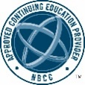
Counselors
Education and Consultative Services of UPMC Western Psychiatric Hospital has been approved by NBCC as an Approved Continuing Education Provider, ACEP No. 5059. Programs that do not qualify for NBCC credit are clearly identified. UPMC Western Psychiatric Hospital is solely responsible for all aspects of this program. This program is offered for a maximum of 5.5 continuing education credits over the three-day conference.

Other Healthcare Professionals
Nurses and other health care professionals are awarded maximum of .55 Continuing Education Units (CEU's) for this day of the conference. One CEU is equal to 10 contact hours. Nurses: For attending this program you will receive a Certificate of Attendance confirming a maximum of up to 5.5 hours of continuing education for this day of the conference. These hours may be considered eligible for completing the 30 hours of continuing education required for biannual nursing re-licensure in Pennsylvania.

- Please retain your certificates in a safe place. Replacements cost $30 for those that come from our office (Gen. CEU; NCC).
- Participants requesting Continuing Education/Continuing Medical Education (CE/CME) credits must attend the entire day. Variable credits are not provided. Your attendance is recorded on the Zoom attendance list.
- Although the evaluation is not mandatory, we appreciate your participation. There are questions that need to be answered so we are aware of your credit request. Please expect the certificates from our office in four to six weeks post-conference. Those obtained from the registration site can be accessed immediately.

Continuing Education Credits – October 15, 2021 (5.5 CE/CME credits)

In support of improving patient care, the University of Pittsburgh is jointly accredited by the Accreditation Council for Continuing Medical Education (ACCME), the Accreditation Council for Pharmacy Education (ACPE), and the American Nurses Credentialing Center (ANCC), to provide continuing education for the healthcare team.

Physician (CME)
The University of Pittsburgh designates this live activity for a maximum of 5.5 AMA PRA Category 1 Credits™. Physicians should claim only the credit commensurate with the extent of their participation in the activity.

Other Healthcare Professionals
Other health care professionals will receive a certificate of attendance confirming the number of contact hours commensurate with the extent of participation in this activity.
Psychologists
As a Jointly Accredited Organization, University of Pittsburgh is approved to offer psychology continuing education by the American Psychological Association. University of Pittsburgh maintains responsibility for this course. Psychologists completing this course receive 5.5 continuing education credits.

Licensed/Clinical Social Workers, Licensed Professional Counselors, Licensed Marriage and Family Therapists: LSW/LCSW/LPC/LMFT
As a Jointly Accredited Organization, University of Pittsburgh is approved to offer social work continuing education by the Association of Social Work Boards (ASWB) Approved Continuing Education (ACE) program. Organizations, not individual courses, are approved under this program. State and provincial regulatory boards have the final authority to determine whether an individual course may be accepted for continuing education credit. University of Pittsburgh maintains responsibility for this course. Social workers completing this course receive 5.5 continuing education credits.
Counselors
Education and Consultative Services of UPMC Western Psychiatric Hospital has been approved by NBCC as an Approved Continuing Education Provider, ACEP No. 5059. Programs that do not qualify for NBCC credit are clearly identified. UPMC Western Psychiatric Hospital is solely responsible for all aspects of this program. This program is offered for a maximum of 5.5 continuing education credits over the three-day conference.

Other Healthcare Professionals
Nurses and other health care professionals are awarded maximum of .55 Continuing Education Units (CEU's) for this day of the conference. One CEU is equal to 10 contact hours. Nurses: For attending this program you will receive a Certificate of Attendance confirming a maximum of up to 5.5 hours of continuing education for this day of the conference. These hours may be considered eligible for completing the 30 hours of continuing education required for biannual nursing re-licensure in Pennsylvania.

- Please retain your certificates in a safe place. Replacements cost $30 for those that come from our office (Gen. CEU; NCC).
- Participants requesting Continuing Education/Continuing Medical Education (CE/CME) credits must attend the entire day. Variable credits are not provided. Your attendance is recorded on the Zoom attendance list.
- Although the evaluation is not mandatory, we appreciate your participation. There are questions that need to be answered so we are aware of your credit request. Please expect the certificates from our office in four to six weeks post-conference. Those obtained from the registration site can be accessed immediately.

Continuing Education Credits – October 16, 2021 (5.5 CE/CME credits)

In support of improving patient care, the University of Pittsburgh is jointly accredited by the Accreditation Council for Continuing Medical Education (ACCME), the Accreditation Council for Pharmacy Education (ACPE), and the American Nurses Credentialing Center (ANCC), to provide continuing education for the healthcare team.

Physician (CME)
The University of Pittsburgh designates this live activity for a maximum of 5.5 AMA PRA Category 1 Credits™. Physicians should claim only the credit commensurate with the extent of their participation in the activity.

Other Healthcare Professionals
Other health care professionals will receive a certificate of attendance confirming the number of contact hours commensurate with the extent of participation in this activity.
Psychologists
As a Jointly Accredited Organization, University of Pittsburgh is approved to offer psychology continuing education by the American Psychological Association. University of Pittsburgh maintains responsibility for this course. Psychologists completing this course receive 5.5 continuing education credits.

Licensed/Clinical Social Workers, Licensed Professional Counselors, Licensed Marriage and Family Therapists: LSW/LCSW/LPC/LMFT
As a Jointly Accredited Organization, University of Pittsburgh is approved to offer social work continuing education by the Association of Social Work Boards (ASWB) Approved Continuing Education (ACE) program. Organizations, not individual courses, are approved under this program. State and provincial regulatory boards have the final authority to determine whether an individual course may be accepted for continuing education credit. University of Pittsburgh maintains responsibility for this course. Social workers completing this course receive 5.5 continuing education credits.
Counselors
Education and Consultative Services of UPMC Western Psychiatric Hospital has been approved by NBCC as an Approved Continuing Education Provider, ACEP No. 5059. Programs that do not qualify for NBCC credit are clearly identified. UPMC Western Psychiatric Hospital is solely responsible for all aspects of this program. This program is offered for a maximum of 5.5 continuing education credits over the three-day conference.

Other Healthcare Professionals
Nurses and other health care professionals are awarded maximum of .55 Continuing Education Units (CEU's) for this day of the conference. One CEU is equal to 10 contact hours. Nurses: For attending this program you will receive a Certificate of Attendance confirming a maximum of up to 5.5 hours of continuing education for this day of the conference. These hours may be considered eligible for completing the 30 hours of continuing education required for biannual nursing re-licensure in Pennsylvania.

- Please retain your certificates in a safe place. Replacements cost $30 for those that come from our office (Gen. CEU; NCC).
- Participants requesting Continuing Education/Continuing Medical Education (CE/CME) credits must attend the entire day. Variable credits are not provided. Your attendance is recorded on the Zoom attendance list.
- Although the evaluation is not mandatory, we appreciate your participation. There are questions that need to be answered so we are aware of your credit request. Please expect the certificates from our office in four to six weeks post-conference. Those obtained from the registration site can be accessed immediately.

Registration – Please register by October 11, 2021 online: 2021 TransPride Pittsburgh Health and Wellness Conference Presented by Central Outreach Wellness Center - October 14, 15, 16, 2021 | UPMC - Center for Continuing Education in the Health Sciences

Full Program Fee Schedule (3 Days):
Physicians (all three days with CME credits) $250
Other Professionals (all three days with CE credits) $200
Students/Interns/Residents (all three days-no continuing education) $25

Two Days Fee Schedule:
Physicians (two-day with CME credits) $200
Other Professionals (two-day with CE credits) $160
Students/Interns/Residents (two-day-no continuing education) $20

One Day Fee Schedule:
Physicians (daily with CME credits) $100
Other Professionals (daily with CE credits) $80
Students/Interns/Residents (one-day-no continuing education) $10

Gender-diverse community members and their parents or direct caregivers, and presenters from the community are welcome to attend free of charge for any part of the conference. Registration is required. There are a limited number of scholarships for students. Please contact Lyndsey Sickler at knottedsouls@gmail.com or Alicyn Simpson at alicyn.simpson@chp.edu for discount codes and additional information and use the Community/Family/Comm.Speakers category when registering (this option is on the registration page).

Tuition includes:
* All registration and conference materials
* Continuing education credits at the professional rate

Please claim your CE/CME certificate by December 31, 2021. The course will be closed following that date.

UPMC employees who would like to be sponsored by their department can request that their supervisor complete a departmental journal form. Registration at the above sites is still required with access codes found here.

Full tuition must accompany your registration. A $20 administrative fee will be deducted from all refunds for cancellations. No refunds can be issued once the program has begun. Please register by October 11, 2020.
We encourage participation by all individuals. If you have a disability, advance notification of any special needs will help us better serve you. Please notify us of your needs at least two weeks in advance of the program by contacting Nancy Mundy at mundnl@upmc.edu.

New Registration Instructions
The UPMC Center for Continuing Education in the Health Sciences (CCEHS) learning portal is used to register, view, track, and manage all your continuing education credits.

If, at any point these directions result in you seeing a blank page in your account, please look at your cart in the upper right-hand corner. If there is anything in there, please click on the cart to see how to proceed (and look at the directions below). Or delete what is in there and begin again. Please contact Nancy Mundy if you have difficulties after attempting the following directions.

- Creating an Account at cce.upmc.com
- Go to https://cce.upmc.com in your browser or just click on the link.
- On Login page, click on “Create Account”
- Complete questions. Please add in your credentials as your degree (MSW, PhD, MD, etc.), and use the dropdown to identify your profession.
- Click on “Save”. Please keep track of your password or store your sign-in information.

- Registering for a Program
- If you have your account set up (see #1), and you’ve logged in, please go to the link of the program that you’ve been sent, or click on the “Catalog” tab, and put the name of the program in the search bar.
- You will be on the program page. Review the information, and click on the “Register” tab. If there is a fee to pay, you’ll see a purple box with “Add to Cart” in it. Please click on this. If there is no fee, you will see the activity in your “Pending Activities” and there is nothing else to complete until after the event.
- Click on “Add to Cart”
- You’ll see the name of the payment page and the appropriate amount. Click on “Checkout”. If you have a discount code, please add this in the coupon box, click on “apply” and then “checkout”.
- Add your billing information on the next page. Please complete all required (*) fields. Please make sure this address is connected to your credit card. Scroll to the bottom of the page and click on “Review Order”
- Enter your payment information and click on “Continue”
- Click on “Submit Order”
- On the next page, click on “View Course Page”. If you go into your “Account”, and then “Courses”, you’ll see this listed in your “Pending Activities”.
- You’ll have to return to your “Pending Activities” once the program has occurred to finish the process and obtain your CE credits/certificate.

- Securing your CE/CME Credits after the conference is over
It’s important to note here that you can secure your CE/CME credits on this system for the following: APA, LSW/LCSW/LPC/LMFT, CME, Attendance. All other CE credits/certificates (NCC, General CEU, CADC/CCDP) will be sent to you via e-mail from a staff member at Education and Consultative Services four to six weeks after the event, once you’ve completed the information requested.

- Log in to your account at https://cce.upmc.com. After logging in, please click on “My Account”, and then “Courses” and then “Pending Activities”.
- Click on the course that’s listed.
- The next page will come up with a purple box “Register/Complete Course”. Please click on that.
- On the left, see “Course Progress”
- Please click on “Complete Course Evaluation” and then “Submit” when completed.
- Return to “Course Progress”, and click in the circle for “Credit” and “Certificate”
- You’ll see a download link on the current page, or you can return to your “Account” and “Courses” and then “Completed Activities” to secure your certificate.

Kacie M. Kidd, Gina M. Sequeira, Claudia Douglas, Taylor Paglisotti, David J. Inwards-Breland, Elizabeth Miller and Robert W. S. Coulter - Pediatrics June 2021, 147 (6) e2020049823; DOI: https://doi.org/10.1542/peds.2020-049823

